

07 Developing as a Team

Contents

Overview 3

7.1. Core Concepts 4

Team Roles 4

Development Methodologies 5

Truck Factor 5

Source Control 5

Burnout and Crunch 5

7.2. Common Mistakes 6

Source Control Is Hard 6

Source Control Is Rarely “Optional” 6

Planning Perfectly Means We Can Just Make It 7

“That’s Just X—They’re Always Working Like That” 7

Exercises 8

Exercise 7A: Investigating Version Control 8

Exercise 7B: Investigating Setup within UE4 11

# Overview

**PURPOSE**

The purpose of this tutorial is to outline some of the more common issues associated with team development and project management.

**SCOPE**

This section will provide an introductory overview of the following:

* Team roles
* Development methodologies
* Source control

**PREREQUISITES**

A basic understanding of the engine and how to use the tools

## 7.1. Core Concepts

### Team Roles

Many people believe that roles within development are split between artists and programmers; however, there is a substantially wider collection of team roles, including but not limited to the following:

#### Project Manager

A project manager oversees projects from a high level. They coordinate members of teams and subteams while ensuring that everyone is working toward a collective aim.

#### Game Designer

A game designer conceives and designs the rules and structure of a game, including game mechanics, controls, narrative, and story and user interface. Their role often involves overseeing the implementation of their designs by team members in other disciplines.

#### Artist

An artist creates visual art for the game. An artist can specialize in 2D art, including concept art, textures, user interface, and environment backgrounds, and in 3D art, including 3D models and animations.

#### Programmer

Programmers develop the software both for the game and to facilitate the development of the game by team members in other disciplines. Common components of a game that a programmer will develop include gameplay, AI, physics, graphics, UI, networking, and development tools.

#### Level Designer

A level designer constructs levels, puzzles, scenarios, and missions for games. Often level designing involves pulling together work from other disciplines to construct the experiences for players.

#### Technical Artist

Technical artists are specialists with proficiency in various processes of 3D graphics rendering. They act as a bridge between programmers and artists to help facilitate the creation of art and its integration into the game as well as to ensure that programmers are aware of the technical requirements of the artists and the art they need to create.

#### Audio Engineers

Audio Engineers record sound effects, music, and voice-overs and prepare them for use within a game.

#### QA Tester

QA testers test all features of a game to find bugs and usability issues while helping to refine and balance various components and mechanics of a game.

#### Infrastructure

Infrastructure team members ensure that the underlying toolsets and infrastructure requirements of a team are in place and stable.

#### Marketing and Outreach

Marketing handles customer interactions and outreach through a range of platforms, including social media, email, and physical media.

### Development Methodologies

#### Waterfall Development

Waterfall development involves a series of sequential and non-iterative tasks in which a project is planned and developed. This model is considered to be a traditional software development approach; however, most teams have switched over to an Agile approach.

#### Agile Development

Agile development is a term used to describe many different submethodologies. At its core, Agile development focuses on the concept of iterative development and design, where a project is constantly iterated and improved upon according to feedback and assessment.

### Truck Factor

At any stage, a team member might no longer be able to complete their role within a team, possibly as a result of burnout, for personal reasons, or because they left the team. This means that teams not only need to have plans in place for how to retrain staff to fill different roles, but also need to have mechanisms in place to understand what workload each member has and how they’ve been developing it.

### Source Control

Source control can save teams or individuals from a wide range of potentially project-ending scenarios while allowing a collaborative development effort.

Unreal Engine 4 comes with two fully integrated methods that allow people to work together on their projects using version control software like Perforce and Subversion (SVN). Version control allows users on a team to share assets and code with one another, as well as providing a backup and history of changes so any file can be rolled back to an earlier version if something goes wrong with it.

### Burnout and Crunch

Over time, it’s easy to inadvertently wear out developers, or even the entire team. As unpredictable events in development occur and deadlines/timelines are altered, the chance of “burning out” team members increases. Where possible, team members need to be aware of their fellow team members’ state of mind and ensure that everyone is acting optimally in a healthy environment.

Following are common symptoms of burnout:

* Physical or emotional exhaustion. This can make you feel tired, weak, drained, or detached.
* Insomnia
* Difficulty concentrating, and forgetfulness
* Getting sick more than usual (for example, with a cold or the flu)
* Unexplained physical symptoms such as headaches, dizziness, or stomachaches. Make sure to get these checked out by a doctor.
* Loss of appetite and/or weight loss
* Anxiety. This not only means feeling nervous, but also can present with a sense of dread, tension, irritability, and racing thoughts that interfere with concentration.
* Depression. This not only means feeling sad, but also can mean feeling guilty, worthless, hopeless, and/or suicidal.
* Loss of enjoyment. This doesn’t have to apply just to work but eventually may spread to areas of social and family life. Please note that loss of enjoyment is also a symptom of depression.
* Pessimism. If you feel detached and ineffective, you may feel disillusioned with your career.
* Isolation. Social interaction is important for mental health and well-being. When employees are experiencing depersonalization, they may not feel like talking to their colleagues, clients, or customers.
* Apathy. “What’s the point in trying?” This attitude further decreases one’s sense of self-worth and purpose.
* Lack of productivity and poor performance

(*Source*: Adapted from Jennifer Hazel, “Crunch and Burnout,” July 28, 2016, CheckPoint, https://checkpoint.org.au/burnout/.)

## 7.2. Common Mistakes

### Source Control Is Hard

There are many online guides to source control, and if your team has difficulty with source control, it may be worth considering a simpler option like SVN.

### Source Control Is Rarely “Optional”

If a project is going to be developed in any way past an isolated testing phase, then source control is almost always essential. It can save a single accident from erasing days, weeks, or even months of hard work and allows teams to work collaboratively and share files with one another.

### “Planning Perfectly Means We Can Just Make It”

Perfect planning is rarely all that is required when developing a game. With the exception of some very small projects, most games go through serious prolonged iteration before they are suitable for release. A feature that was planned out months in advance can often need multiple redesigns before it suits the intention of the initial design.

### “That’s Just X—They’re Always Working Like That”

Just because a team member is constantly working doesn’t mean it’s necessarily healthy for them to be allowed to continue. People need to realistically evaluate the state of the team member and look for ways that they can reasonably prevent them from burning out. In some ways, the benefits of crunch can feel addictive, but over a period of time crunch can cause serious damage to both individuals and teams.

Exercises

## Exercise 7A: Investigating Version Control

**Deliverables:** Activity sheet (see below)

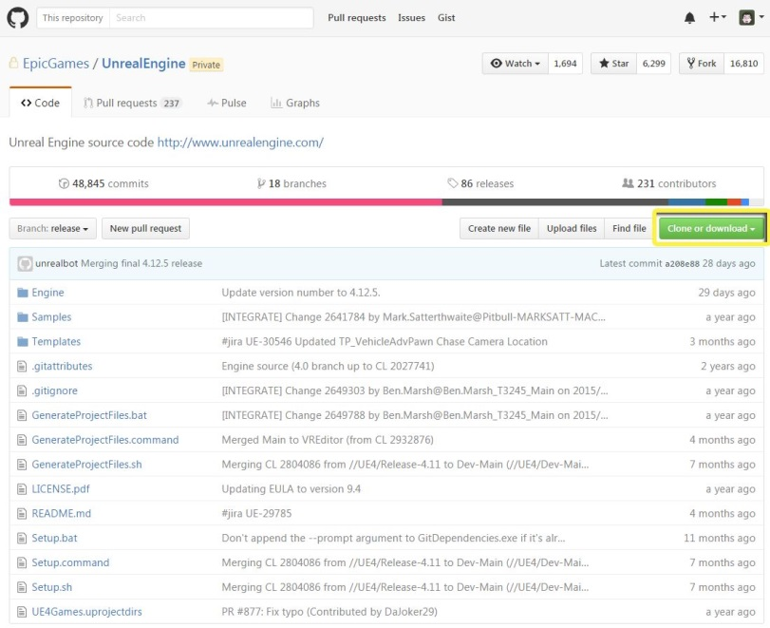

**Instructor Task:** Briefly discuss version control methods and demonstrate a working example (for instance, log into the Unreal Engine 4 repository on GitHub).

**Student Task:** Pick one of the following popular methods of version control:

* Git
* Perforce
* SVN

You will need to research your chosen method and provide answers to the questions on the activity sheet.

Activity Sheet 7A

|  |  |  |  |
| --- | --- | --- | --- |
| Name: |  | Date: |  |

Chosen System (Circle): GIT / Perforce / SVN

1. Overview of Operation (What does it do? What is it for?)

__________________________________________________________________________________________________________________________________________________________________________________________________________________________________________________________________________________________________________________________________________________________________________________________________________________________________________________________________________________________________________________________________________________________________________________________________________________________________________________________________________________________________________________________________________________________________________________________________________________________________________________________________________________________________________________________________________________________________________________________________________________________________________________________________________________________________________________________________________________________________________________________________________________________________________________________________________________________________________________________________________________________________________________________________________________________________________________________________________________________________________________________________________________________________________________________________________________________________________________________________________________________________________________________________________________________________________________________________________________________________________________________________________________________________________________________________________________________________________________________________________________________________________________________________________________________________________________________________________________________________________________________________________________________________________________________________________________________________

1. Deployable Platforms (Windows / Mac / Linux / Android / Browser)

____________________________________________________________________________________________________________________________________________________________________________________________________________________________________________________________________________________________________________________________________________________

1. Cost of System (Subscription/Cost per Unit, Hardware Resources)

____________________________________________________________________________________________________________________________________________________________________________________________________________________________________________________________________________________________________________________________________________________

1. Accessibility (Learning Curve, Methods of Access)

____________________________________________________________________________________________________________________________________________________________________________________________________________________________________________________________________________________________________________________________________________________

1. Security and Protection (Data Backups / Data Security)

____________________________________________________________________________________________________________________________________________________________________________________________________________________________________________________________________________________________________________________________________________________

## Exercise 7B: Investigating Setup within UE4

**Deliverables:** Activity sheet (see below)

**Instructor Task:** Have the students provide an overview of the process required to set up a working example of their chosen method of version control.

**Student Task:** Investigate the process required to get your chosen method of version control working with Unreal Engine 4.

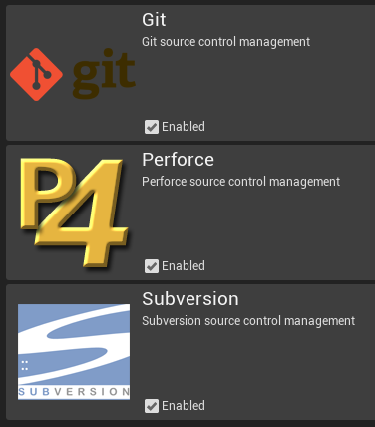

|  |  |
| --- | --- |
| C:\Users\Melanie Nikdel\AppData\Local\Microsoft\Windows\INetCache\Content.Word\tips-png-4.png | For more information on source control in UE4, see  <https://docs.unrealengine.com/latest/INT/Engine/Basics/SourceControl/index.html>. |

Activity Sheet 7B

|  |  |  |  |
| --- | --- | --- | --- |
| Name: |  | Date: |  |

Description (Briefly describe the setup and Unreal Engine integration process.)

_______________________________________________________________________________________________________________________________________________________________________________________________________________________________________________________________________________________________________________________________________________________________________________________________________________________________________________________________________________________________________________________________________________________________________________________________________________________________________________________________________________________________________________________________________________________________________________________________________________________________________________________________________________________________________________________________________________________________________________________________________________________________________________________________________________________________________________________________________________________________________________________________________________________________________________________________________________________________________________________________________________________________________________________________________________________________________________________________________________________________________________________________________________________________________________________________________________________________________________________________________________________________________________________________________________________________________________________________________________________________________________________________________________________________________________________________________________________________________________________________________________________________________________________________________________________________________________________________________________________________________________________________________________________________________________________________________________________________________________________________________________________________________________________